IHCL Project SAPLINK-II Integration Design Strategy- TajSATs-Draft-V1.0

Table of Contents
Glossary 3
1. Introduction 4
1.1. Purpose 4
1.2. Objective 4
1.3. Scope 4
2. Proposed High-Level Integration Architecture 5
3. Integration Design Strategy 5
3.1. SAP BTP Integration Suite (CPI) 5
3.1.1. Functionality 5
3.1.2. Key Capabilities & Benefits: 5
3.1.3. Supported Adaptors 6
3.2. Security Standards 6
3.3. Integration Assumptions 7
3.4. Communication Scenarios 7
3.5. Integration Scenarios with TajSATs 9
3.6 Error Handling 9
3.7 Applicability of patterns to use cases 10
3.8 Network & Firewall Rules 11
3.9 Environments & Transport Mechanism 11
3.10 BTP Integration Suite Environment & Transports 12
3.11 CPI Monitoring 12
4. Factors to consider while designing the interface 13
4.1 Synchronous Vs Asynchronous 13
4.2 Interface Frequency 13
4.3 Interface List 13

Glossary
Term or Abbreviation | Definition
CPI | Cloud Platform Integration
SOAP | Simple Object Access Protocol
REST | Representational State Transfer
JDBC | Java Database Connectivity
SFTP | Secure File Transfer Protocol
IS | BTP Integration Suite
ODATA | Open Data Protocol
ALE | Application Link Enabling
IDoc | Intermediate Document in SAP
ERP | Enterprise Resource Planning
SD | Sales & Distribution
MM | Material Management
PM | Project Management
EMIS | Event Mesh Integration Suite
ISO | International Organization for Standardization
CC | Cloud Connector
ISAE | International Standard for Assurance Engagements
EXM | Exception Management
ICMON | Interface and Connection Monitoring
HTTPS | Hypertext Transfer Protocol Secure
IP | Internet Protocol
BOM | Bill of Materials
IDE | Integrated Development Environment
IFlow | Integration Flow
S-User | It is unique identifier that allows user to login to SAP Portal
API | Application Programming Interface
AS2 | Application Statement 2 standard
JDBC | Java Database Connectivity

1. Introduction

1.1. Purpose

A robust Integration strategy is crucial for any integration project as it provides an insight to the organization's principles and guidelines and forms the basis for future integration projects, ensuring consistency, uniformity, visibility, data security and integrity across the landscape.

This document will be the rule book for the integration team and will act as a reference for current and future integration projects. It will also list the available products and solution identified for building integration between various systems in the IHCL landscape with IHCL Hotels, Ginger Hotels, Qmin & TajSATS all coming under a single landscape
This document should be revised and updated at regular intervals, to be aligned with landscape/functional changes in IHCL.

1.2. Objective
The key objective of this document is to provide:
- Feasible options available to build integration scenarios
- Integration & Design Strategy for the Enterprise
- Proposed Solution Architecture
- Principles and Guidelines to be adhered during integration
- Security standards used for data encryption
- Logging & Monitoring

1.3. Scope
In-scope | - Key integration strategy and architectural decisions  - Integration of security considerations and recommendations  - Integration Error handling and Retry  - Integration Monitoring capabilities  - Application security integration for SAP components  - Integration Architecture overview consisting of functional components and technical components along with solution landscape that are in the scope of project SAP Link-II covering Ginger Hotels, Qmin & TajSATS.  - Information flow between SAP to Third Party Systems, Cloud Systems and Peripheral applications that are in scope of project SAP Link, hereafter referred as Non-SAP Applications.
Out-of-scope | - Documentation of the current architecture of the connected application  - Creation of current IHCL landscape and architecture document  - Capacity planning and sizing as part of the overall operational model  - Infrastructure design would be part of the overall Infrastructure document  - All data migration activities. This will be part of the Data Migration Strategy  - Low level design of application integration will be covered during realization Phase

2. Proposed High-Level Integration Architecture

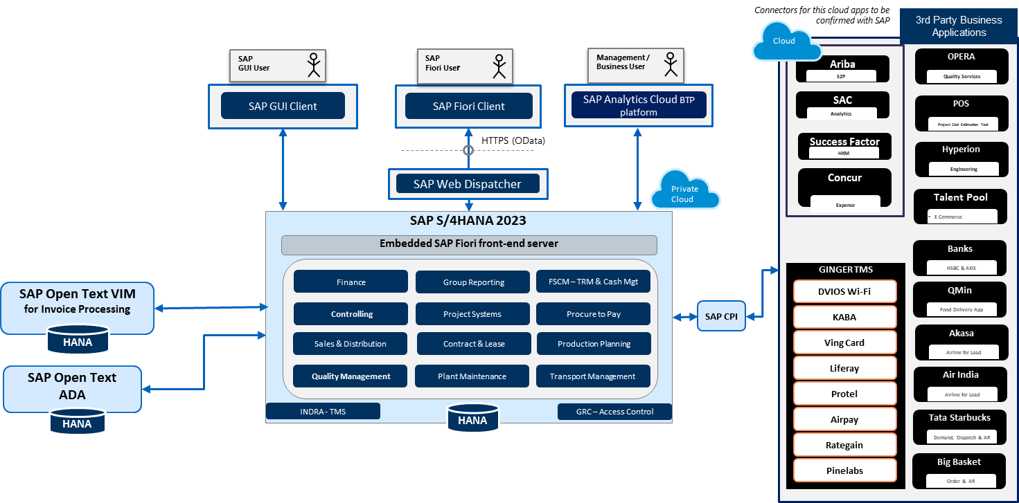

3. Integration Design Strategy
IHCL’s To be landscape will consist of SAP On-Premises Applications as well as cloud applications and third-party applications.
Hence it is recommended to have SAP BTP Integration suite for integration scenarios.

3.1. SAP BTP Integration Suite (CPI)

3.1.1. Functionality
- Cloud Based Paas, Stable and robust integration application for ERP implementation
- Preferred for Cloud to Cloud, Hybrid, SAP & Non-SAP integration.
- Message routing and security handling
- Logging & Monitoring

3.1.2. Key Capabilities & Benefits:
- A single solution to orchestrate business process
- Prepackaged content for different SAP products
- Cloud Integration: Organizations that transition to cloud, it is necessary to consider the many elements that need to be unified. Businesses must integrate different systems and applications in hybrid landscapes that are developed and maintained on different technology stacks, following different security standards, with different business interface specifications. The Cloud Integration capability of SAP Integration Suite enables enterprises to connect these various applications quickly and seamlessly, regardless of the landscape.
- API Management: The suite’s API Management capability provides a central layer to govern, manage, and meter APIs. It provides a code-free, web-based framework to design new APIs, manage existing APIs, enrich APIs with security and access policies, make logical groupings using product catalogs, and offer APIs via a developer portal to the community. You can also associate rate plans with APIs to monetize API access. An API-based integration approach focuses on providing a plug point that can be used to support the creation of applications and extensions, as well as the integration of businesses.
- Open Connectors: The Open Connectors capability of SAP Integration Suite provides third-party connectors via a unified REST API layer, with normalized authentication, error handling, and connectivity mechanisms.
- SAP API Business Hub: SAP shares a reference architecture of which solutions are required to become an intelligent enterprise and the target state of enterprise architecture. Organizations can now explore how E2E processes can be broken down into applications, modules, business services, technologies, and integrations. All integration content is linked, such as APIs for integration.

3.1.3. Supported Adaptors
Adapters are pre-built connectors that provide out-of-the-box connectivity to a wide range of systems and data sources, such as SAP ERP, Salesforce, Amazon S3, and FTP servers. SAP CPI (Cloud Platform Integration) includes a rich set of adapters that support different protocols and integration scenarios

Adapter Type | Message formats
HTTP | XML, JSON
SFTP | XML, CSV, Plain Text etc.
JDBC | XML SQL
File/FTP | File with content conversion, Plain Text
JMS | JMS 1.x
SOAP | SOAP 1.1
OData | JSON
Mail | Mail
AS2 | EDIFACT, X12, TRADACOM etc.
AMQP | XML, JSON etc.

3.2. Security Standards
CPI supports encryption of data at various levels:
- Message-level encryption for secure message content (PGP, PKCS#7)
- Transport level encryption for secure message content (HTTPS, SSL, SSH, etc.)
- Data stream encryption via Secure Sockets Layer (HTTPS)
- Basic, Certificate, OAuth, SAML, SSH and Token based Authentication ➢ AS2 supports EDIFACT, ANSI X12, TRADACOM etc.
- Supported Algorithms for encryption (AES_128, AES_192, AES_256)
- Supported Algorithms for Signing (MD5, SHA256, SHA384, and SHA512)

3.3. Integration Assumptions
- Functional Leads will provide the interface information from the AS-IS system i.e., SDDs, Functional specifications, Mapping requirement specifications etc.
- Development will start after receiving approval from IHCL.
- Non-Functional requirements (Message Volume, Payload size, System Performance and work processes, Network testing, Penetration testing, Scaling & Latency) need to be reviewed in detail during realization phase as these will have an impact on interface design in co-ordination with testing team.
- The IHCL team will provide stakeholder managers for integration team to bridge the gap/decision making between multiple stakeholders.
- The IHCL team’s support is needed for Network connectivity between IHCL and Third-Party Applications like IP Netting, Port opening, Firewall Configuration, etc. in applicable cases.
- SAP API Management, Enterprise Messaging (EMIS), Open Connectors will be used based on the integration scenario adhering to licensing.

3.4. Communication Scenarios

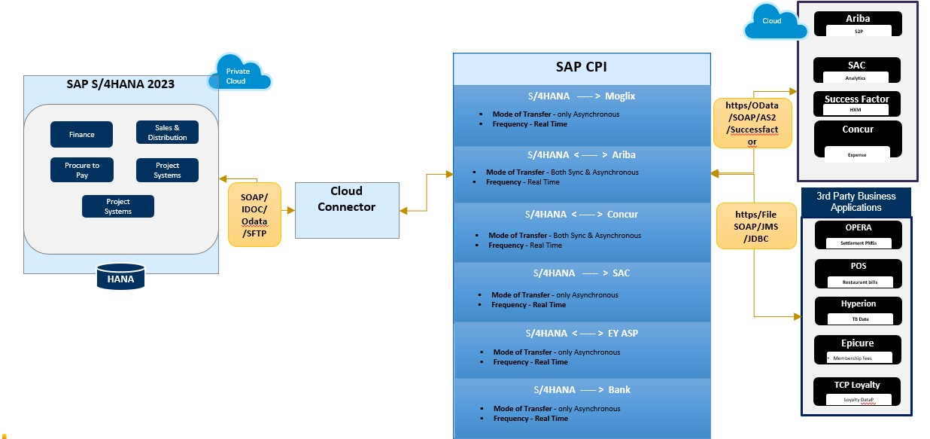

Note: No System will connect to SAP S/4 HANA directly. They will connect via Cloud Connector only.

A. Cloud to SAP S/4 HANA:

- This Communication scenario involves integration with SAP cloud products ARIBA, Success factor, Concur, SAC etc.
- For Inbound Scenario, CPI will receive request message from Cloud systems. CPI will perform logging and transformation on message using converters, message mapping, groovy script etc.
- This transformed message will be then forwarded to SAP S/4HANA via cloud connector (CC).
- For Outbound Scenario, CPI will receive request message from SAP S/4 HANA directly via secure channel which will be established between CPI and S/4 HANA. CPI will perform logging and transformation on message using converters, message mapping, groovy script etc. This transformed message will be then forwarded to Cloud Systems.
- Mode of Communication (Sync/Async) and adapter will change as per business scenario and system support.

B. Third Party System (Cloud/Internet Based) to SAP S/4 HANA:
- This Communication scenario involves integration with Third Party systems like POS, Hyperion, Opera, Epicure, TCP Loyalty, XN-POS, Qmin, Big basket, Tata Starbucks, Air India, Akasa, etc.
- For Inbound Scenario, CPI will receive request messages from Third Party systems. CPI will perform logging and transformation on message using converters, message mapping, groovy script etc. This transformed message will be then forwarded to SAP S/4HANA via cloud connector (CC).
- For Outbound Scenario, CPI will receive request messages from SAP S/4 HANA directly via secure channel which will be established between CPI and S/4 HANA. CPI will perform logging and transformation on message using converters, message mapping, groovy script etc. This transformed message will then be forwarded to Third Party systems.
- Mode of Communication (Sync/Async) and adapter will change as per business scenario and system support.

C. Third Party System (On-Premises) to SAP S/4 HANA:
- This Communication scenario involves integration with Third Party systems like Banks (HDFC, Kotak, Axis, ICICI and HSBC) which have their SFTP server On-Premises or any On-Premises database or FTP etc. So, this will work as On-Premises to On-Premises communication.
- Such type of connections requires On-Premises system to be registered under cloud connector connections.
- For Inbound Scenario, CPI will receive request message from Third Party systems via CC. CPI will perform logging and transformation on message using converters, message mapping, groovy script etc. This transformed message will be then forwarded to SAP S/4HANA via cloud connector (CC).
- For Outbound Scenario, CPI will receive request message from SAP S/4 HANA directly via CC. CPI will perform logging and transformation on message using converters, message mapping, groovy script etc. This transformed message will then be forwarded to Third Party systems.
- Mode of Communication (Sync/Async) and adapter will change as per business scenario and system support.

3.5. Integration Scenarios with TajSATs
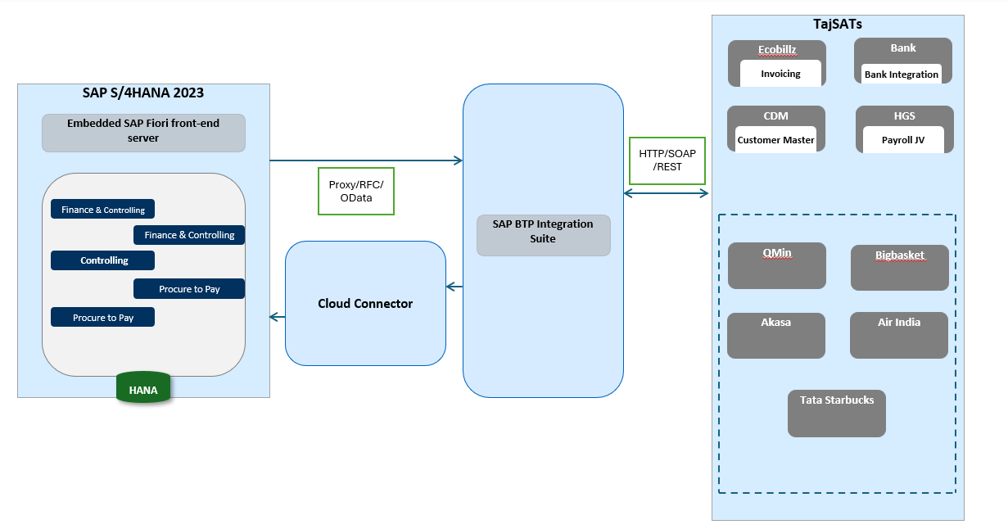
- This Communication scenario involves integration with Third Party systems like Qmin, Big basket, Akasa, Air India, Starbucks, etc... These involve integration via API and follow approach of Cloud to On-premises and vice-versa.
- As is model includes interfaces via SAP PI/PO with SAP ECC. To be model will migrate the same approach and follow the same connectivity and integration of objects.
- Migration of existing proxies from Enterprise Service Repository to Metadata Repository proxies.
- Proxy connectivity will be replaced with XI in CPI and RFC will be kept unchanged.
In terms of other data conversions and transformations CPI relevant configurations will be used.
- Existing integrations of HGS, Banks and CDM will be utilized to extend TajSATs integration.
- Mode of Communication (Sync/Async) and adapter will change as per business scenario and system support.

3.6 Error Handling
The pattern is used to catch any exceptions thrown in the integration process and handle them. The process always starts with “Error Start” event and ends with either End Message or Error End or Escalation event. Additional Service Calls can be added to the pattern to enable calling other systems to handle the exception. The pattern should preferably be used in all custom flows to enable error handling.
For Async Calls, a retry mechanism is to be established for failed calls in CPI end. Message will set to error status if it is not delivered even after multiple retries. Such messages are to be retriggered from the sender end.
For Sync Calls, exception messages will be raised and sent back to source system so that sender can correct issues with messages and resend.
Alert mechanism will be set up in both S/4 HANA and SAP CPI.
Alert mechanism will be set up in SAP CPI for triggering alerts/mail for any failure of messages. Respective email group is to be provided by IHCL.

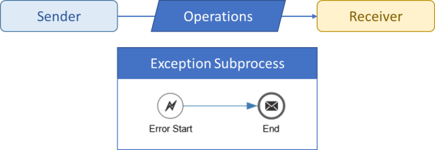
Figure: Exception Handling
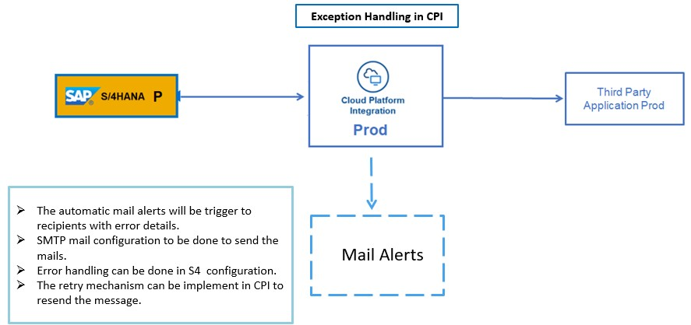

3.7 Applicability of patterns to use cases
Following is a summary for use-cases of stateless patterns and their applicability to SAP Link program.

Message Routing
The following tables describe the patterns for Message Routing and their Applicability solution:

Pattern Description | Use Case (when to use what?)
Point to Point | There is a single sender and a single receiver, the data needs to be sent unidirectional.
Request Response | There is a single sender and a single receiver, the data needs to be sent bidirectional.
Content Based Router | There is more than one potential Receiver of the Message. Based on Data (message Payload), the message is sent to exactly one of the receivers.
Recipient List (Splitter) | There is more than one potential Receiver of the Message. Based on Data (message Payload), the message is sent to one or many receivers.
Splitter | In this pattern, the message might need to go to multiple receivers (Like the Recipient List pattern). However, for each receiver, specific data filtering is applied to send the data relevant for that receiver only.
Message Filter | In this case, like the Content Based Routing / recipient list, conditions are applied to determine the receiver. The difference is, in this pattern, it is expected that CPI will receive which will not resolve to any receiver

Message Transformation

The following patterns are available for Message Transformation:

Pattern | Use Case (when to use what?)
Content Enricher | Additional information needs to be fetched from an external system before sending the data to the target system. This can be achieved by performing lookups from mappings.
Content Filter | When a subset of the data needs to be sent to the target system. This is achieved by using mapping capability.

3.8 Network & Firewall Rules
We understand communication outside IHCL landscape is processed through firewalls managed separately by IHCL Network and Third-Party Applications.
Required Communication details are to be shared in below format with IHCL and Third-Party Network Team to allow communication on respective firewalls:
Access  Policy  Rules |  | Source IP  Address /  Network | Destination IP Address / Network | Port | Service (TCP / UDP / ICMP) | Action  (Allow/Deny) | Duration | Remarks / Business  Justification
IHCL and Third-Party Team will be responsible for applying rules and managing communication at their respective firewalls.

3.9 Environments & Transport Mechanism
File transport mechanism will be used as CTMS service is not subscribed as of now.

3.10 BTP Integration Suite Environment & Transports
In BTP Integration suite, the Objects are built in development environment and Unit Tested and UAT will be performed on same. Post UAT signoff, transports are moved to Production environment.

As SAP S/4 HANA has 3 environments so Development CPI will connect to DEV and QA and Production CPI will connect only PRD.

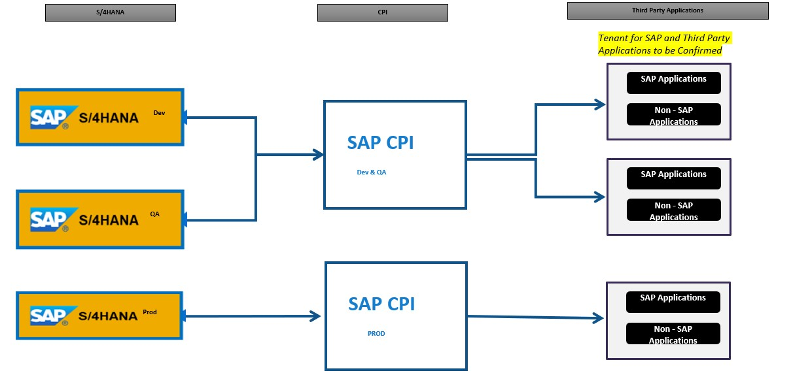

An inventory sheet needs to be maintained that has the list of changes, which details all the activities that need to be performed across various integration systems Monitoring.

3.11 CPI Monitoring
We can access monitors from the Process Orchestration start page. To access the monitoring tools, open a browser and go to http(s)://<host>:<port> /shell/monitoring. <host>: CPI Tenant host & <port>: CPI Tenant Port

Message Monitoring
With the message monitor in CPI, we can monitor the processing of messages. We can use message monitoring in the following cases:
- To create an overview of message processing. Message overview gives an overview of message processing as well as two different modes for searching for messages.
- To track the status of messages.
- To find errors that have occurred and to establish what caused them.

Manage Integration Content
We use manage integration content to see status of artifacts (started, stopped or deployed etc.). From this only we can enable or disable log level of a particular I flow/Artifact.

Manage Security
All security related documents like certificates, user credentials, keys are maintained on security. It also has functionality to test connectivity with multiple adapter/protocol.

Manage Stores
Here we can manage different data stores which can be used to store data in CPI. Also, it has facility to store variables, Number ranges and Queues.

4. Factors to consider while designing the interface

4.1 Synchronous Vs Asynchronous
Synchronous is a two-way (request and reply) communication pattern where both sender and receiver handshake to complete the transaction. Asynchronous is a one-way (fire and forget) communication pattern where sender will not wait for response from the receiver to complete the transaction.
Synchronous communication is always performance intensive as all the systems wait for the response till the transaction is processed and message restart is not a possibility in case of failure. So, it is always advisable to use synchronous communication only if it is a business requirement and it is a business critical process e.g. Credit Card Payment systems otherwise always use asynchronous communication.
Even if the requirement is to have the response of a particular transaction, evaluate the requirement to check if it can be converted to 2 asynchronous integrations 1st for actual transaction and 2nd for acknowledgement e.g. Sales Order Create (Inbound to S/4HANA Cloud) and Sales Order acknowledgement (Outbound from S/4HANA Cloud).

4.2 Interface Frequency
The number of times an interface triggered per day is the frequency of interface, this is mainly used to design the interface, define monitoring and error handling techniques.
Interface frequency is an important criterion while designing the interfaces. Real time scenarios are required for business-critical interfaces requiring the individual transactions to be processed immediately and batch interfaces are required to process the bunch of data that can be processed in batches.
The batch duration shall be decided based on business-criticality, the amount of data being processed in the batch. One another important aspect during interface discussion is how message shall be passed to the target application once the batch is received in CPI.
CPI can pass the data in one go or split it into individual messages based on the target system requirement.

4.3 Interface List
Below is the initial list of interfaces considered, however the final list of interfaces will emerge after the completion of functional process documents.
Sr. No. | Business Area | Process Group (L1) | Process  Scenario (L2) | Business Scenario (L3) | Integration Requirements | From  Application |  |  |  | To Application
1 | Finance | Invoice to Pay | Invoice  Processing | All category of invoices | QR validation with GST Portal | SAP-DCS |  |  |  | EXT-GST  Portal
2 | Finance | Invoice to Pay | Payment Processing | Host to Host  Payment - Hotels,  HSBC Bank | Domestic Payments, Foreign Payments,  Advance Payments, Ad-hoc / Urgent  Payments  IHCL to Bank Host to Host | SAP-S4 |  |  |  | EXT-BANKHSBC
3 | Finance | Invoice to Pay | Payment Processing | Host to Host  Payment - Hotels,  HDFC Bank | Domestic Payments, Foreign Payments,  Advance Payments, Ad-hoc / Urgent  Payments  IHCL to Bank Host to Host | SAP-S4 |  |  |  | EXT-BANKHDFC
4 | Finance | Invoice to Pay | Payment Processing | Host to Host  Payment - Corporate, Kotak  Bank | Domestic Payments, Foreign Payments,  Advance Payments, Ad-hoc / Urgent  Payments  IHCL to Bank Host to Host - | SAP-S4 |  |  |  | EXT-BANK-  Kotak
5 | Finance | Invoice to Pay | Payment Processing | Host to Host  Payment -  Corporate, Axis  Bank | Domestic Payments, Foreign Payments,  Advance Payments, Ad-hoc / Urgent  Payments  IHCL to Bank Host to Host - | SAP-S4 |  |  |  | EXT-BANK-  Axis
6 | Finance | Invoice to Pay | Payment Processing | Host to Host  Payment -  Corporate, ICICI  Bank | Domestic Payments, Foreign Payments,  Advance Payments, Ad-hoc / Urgent  Payments  IHCL to Bank Host to Host - | SAP-S4 |  |  |  | EXT-BANK-  ICICI
7 | Finance | Invoice to Pay | Payment Processing | Statutory  Payments - TDS/VAT/GST  return | Payment executive to login on respective government site and  generate draft challan for statutory payments | SAP-S4 |  |  |  | EXT-GOVT  Pay
8 | Finance | Expense Manageme  nt | Payment Processing | Staff  reimbursement | IHCL to Bank Host to Host -  HDFC for Staff Reimbursement | SAP-S4 |  |  |  | EXT-BANKHDFC
 |  |  |  |  | Unregistered, SEZ, Travel Agent), PAN, GSTN, IATA, City, Address
9 | Finance | Master Data | Master Data  Management  (customer) | Creation /  Amendment /  Change,  Governance | To sync CDM master with SAP Customer master  CDM Account Number, Name, Type  (Registered, Unregistered, SEZ, Travel  Agent), PAN, GSTN, IATA, City, Address |  | EXT-CDM |  |  | SAP-S4
10 | Finance | Bill to Cash | Billing | Fetch EInvoice information from portal | SAP-S/4 HANA for E-invoice generation through SAP-DCS to GST portal through API |  | SAP-DCS |  |  | EXT-GST  Portal
11 | Finance | Bill to Cash | Billing | Digital Signature of hotel FC on Invoices | Attach Digital Signature of unit head on documents |  | EXT-  DMS(Invoice) |  |  | EXT-DSC  (sign)
12 | Finance | Bill to Cash | Cash  Application | All category of collections and cash applications | Receiving MT940 from Bank and sharing payment files to Bank |  | EXT-Banks (Rec) |  |  | SAP-S4
13 | Finance | Bill to Cash | Cash  Application | Travel Agents | Receiving MT940 from Bank and sharing payment files to Bank  Downloading reports from TA website and file formatting - RPA to upload verified reports in SAP |  | EXT-TA website |  |  | SAP-S4
14 | Finance | Record to Report | Payroll Posting | Payroll Posting | Payroll Journal entries from HGS |  |  | SAP S/4 | EXT-HGS

** Note that, Integrations will be tracked separately in the file below:
IHCL SAP Link - Integration Tracker_v1.0.xlsx

